**Digital Twin Tag Meeting Minutes**

**Date:** February 8th, 2023

**Location:** [Microsoft Teams Link](https://teams.microsoft.com/l/meetup-join/19%3ameeting_MDhjNTg4ZDktZGFlYy00ODc0LTliYzQtMjc4MTA3ZTc3NmQ1%40thread.v2/0?context=%7b%22Tid%22%3a%22d41fdab1-7e15-4cfd-b5fa-7200e54deb6b%22%2c%22Oid%22%3a%222516780d-2412-48c9-8447-e24d7322175f%22%7d)

**Discussion Notes**

* Architecture
  + Eliko – Server from Vendor
    - Tracking
  + Real Time Visual / UI
    - Similar to web interface from Eliko but our own control
    - Definition of zones
    - Control hardware
    - Tag/ WIP # Assignment Tool
      * Write 6 digit WUP to tag alias using Eliko API
  + Aggregator – Cloud Application (push)
    - Every 5 - 10 minutes (push)
  + Cloud Services – Storage (Amazon)

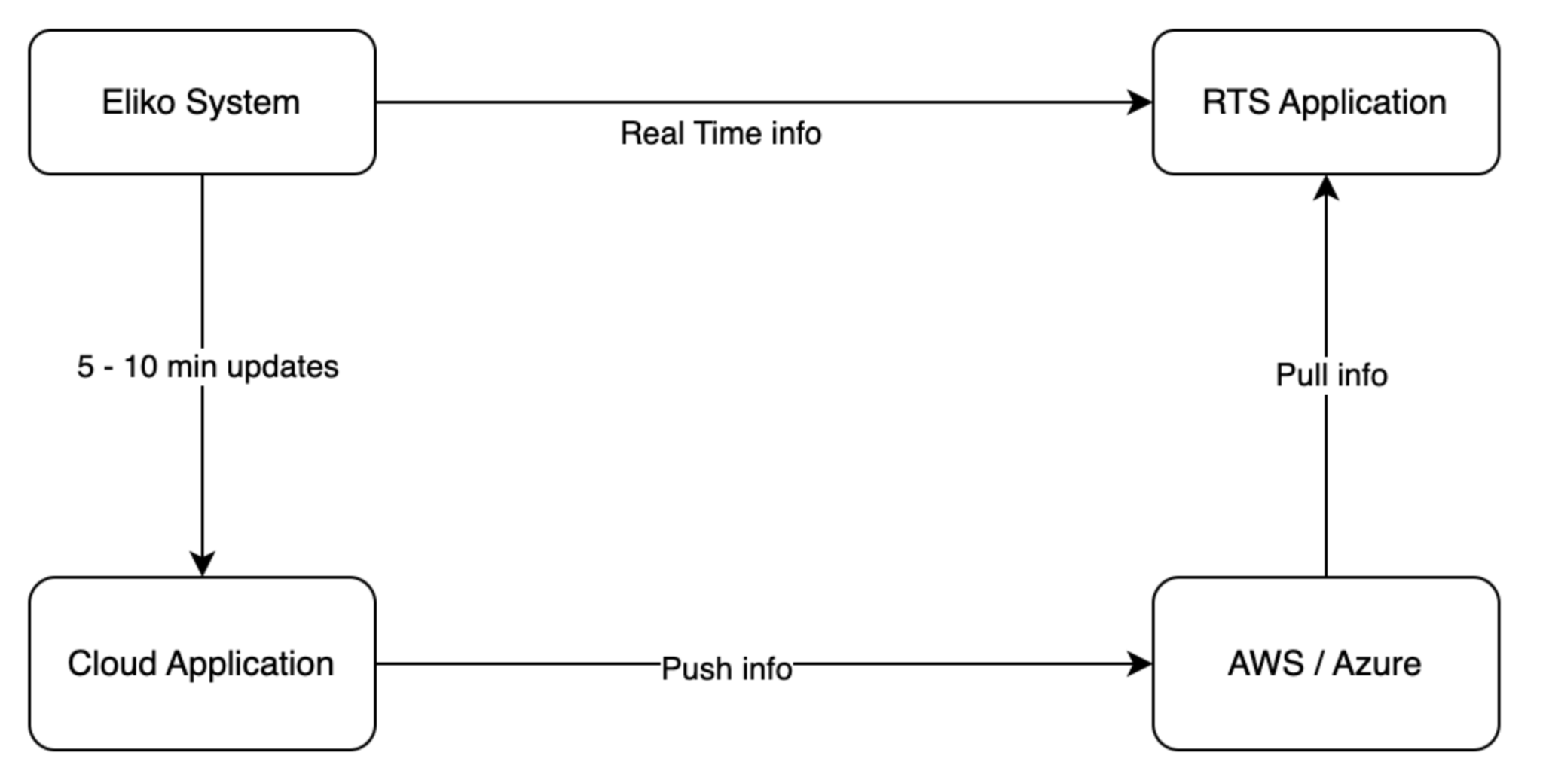

* Manufacturing
* Pull up an order number where is it on the floor – zone ID or position
* 80 tags
* Tool where you link serial number to serial number order (WIP)
* Use Eliko to write WIP number to serial number
* There can be a null case
* Tool used to see if product has been sitting on the floor for too long

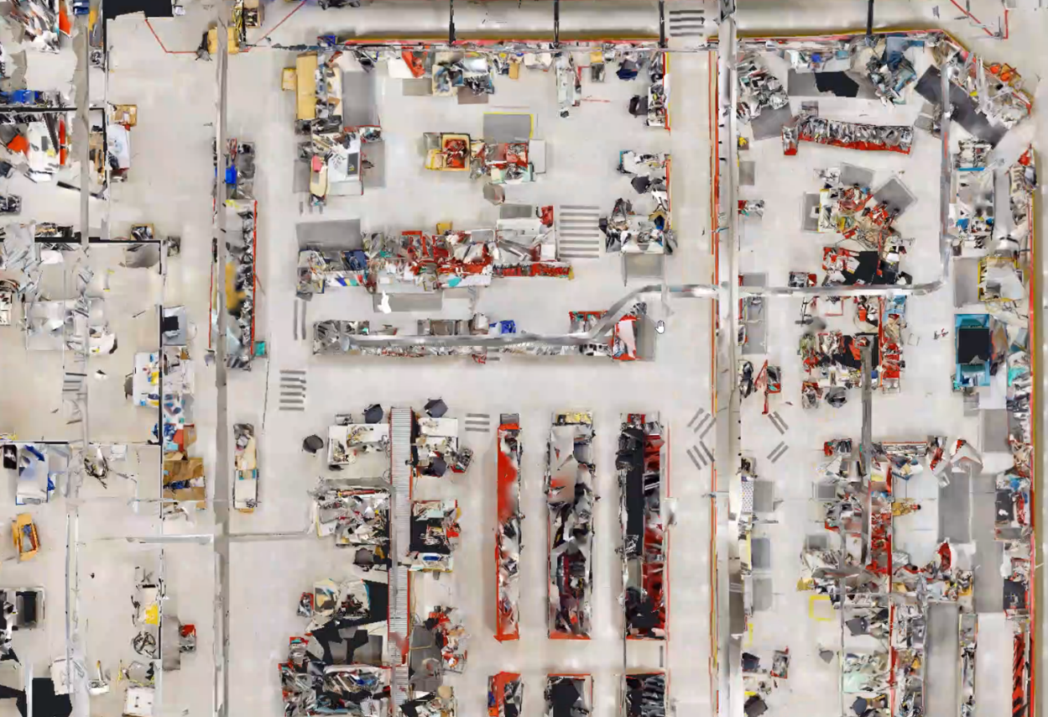

* Sample Data
  + Currently looking for tools for cloud services
  + Need to get a more accurate quote
  + Ryan – bias towards Amazon as they already have services with them
  + Will upload Sample Data
    - 1h Sample
    - 24h Sample
    - All tags in production
  + Custom Report API call
  + You can define zones with API call
  + Where is it best to define and store the zone data
* Updates on VPN
* Inform looking for cloud storage tools
* Prototyping by next

Present Architecture to Ryan:

* immediate need is for the manfacturing side need to pull up order # from the sales side and see where it is on the floor
* see what zone it is in (talking about 80 tags x however many data variables per tag, lets say 400 data objects being pushed to cloud)
* matt walker was asking for tool which can link the tag serial # which eliko has (each tag already has a serial #) and each order has a serial
* #/wip #, need to add the wip number to the tag serial #/tag alias using the eliko api, would get the data flowing quickly, rn manual where user
* has to find the tag and relate it to the wip # manually
* prompt to scan the tag and wip could be done in front-end
* to identify orders that have been sitting on the floor for way too long
* Upload some of the sample data so that (whats your ball park?)

Storage Budget

* doesn't have a ball park value but doesn't expect that it shoud cost too much for something like this
* would prefer that we use AWS for storing out data as bauer already uses it
* initial importance is to work on data
* two ways to operate eliko system

Proposing to change the stack

* ryan doesn't have a preference for what ide and such is used but wants something functional and would prefer python so that it can be mantain in the future
* doesn't mind th echange in the stack and supports the decision
* pyqt5 is not a requirement

Target to Give you A Figma/Front-End

* Adding ryan to the Jira
* will provide us with reqs in a list and we can populate the jira with tickets ourselves

**Action Items**

* Based on the requirements provided by the client we will be populating the Jira board with tickets and assigning them to group members accordingly